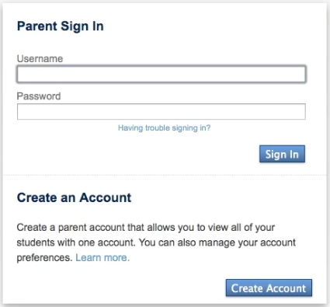 | Use this document as a reference when setting up your Single Sign-On account.  To Begin, go to the PowerSchool web site at http://lmcsd.powerschool.com/  If you’ve never created an account on this web site, click the ‘Create Account’ Button.
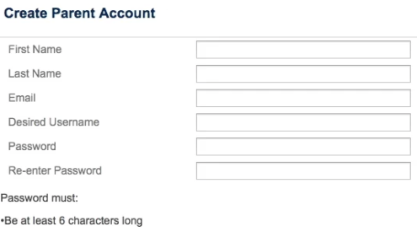 | Enter all the information in the top section of the web page.  The username and email address cannot be the same as another parent SSO account already in the system.  Choose a secure password, preferably 6 characters or more, with a mixture of UPPER and lower-case letters, and numbers.

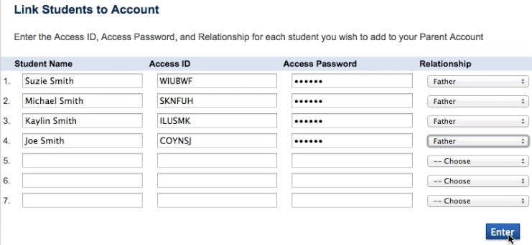
Enter the names, Access IDs and Access Passwords* for your students. The Access ID and Access Password are the same Usernames and Passwords you are currently using to access each individual student’s information in PowerSchool.

Select the relationship type that most accurately reflects your biological or legal relationship with each student.**
Click the ‘Enter’ button when finished.

* If you do not have the Access ID and Access Password, contact the school where your child attends for assistance. For your and your student’s security, the school will need to verify your identity, so you may be asked to make a personal appearance with a Photo ID.

** You can enter up to seven students when initially creating your account. If you need to set up any additional students, you can do so once you log in by clicking the ‘Account Preferences’ link on the left side of the page, and then by clicking the ‘Students’ tab.

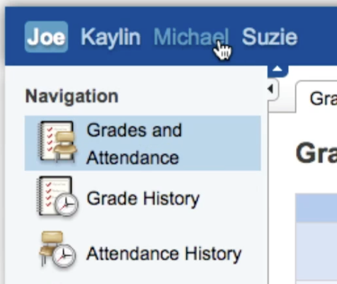 | Once you log in, you’ll now see each student that you have access to in the upper left corner of the screen.  Click on any student’s name to see their information.
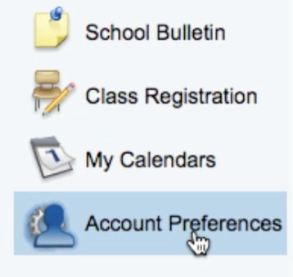 | You can manage your account by clicking the ‘Account Preferences’ icon on the left side of the page.  This will allow you to:  - Change your name  - Change your username  - Change your email address  - Change your password  - Add additional students

